Implementation of the Arithmetic & Logic Unit

Craig Huff
CS 147 Section 01
San Jose State University
craig.huff@sjsu.edu

Abstract— This report will detail the design and implementation of the Arithmetic and Logic Unit (ALU) using the ModelSim simulator. The report will contain:
- Steps to install the simulator, ModelSim, and the setup process for a project.
- Implementing the ‘CS 147 DV’ commands into the ALU
- Implementing test methods for the ALU using the Verilog HDL language
- Running a simulation
- Generating waveforms from the ALU using the test methods

Installing ModelSim
The ModelSim program can be downloaded for free from
http://www.mentor.com/company/higher_ed/modelsim-student-edition using any web browser. After navigating to the website, select “Download Student Edition” and direct the computer where to save the installer. To ensure the program will install properly, there are five steps: (1) Run the installer and complete the installation process. (2) Using the same web browser as before, a form will appear which requires the user to fill with their basic information. The necessary fields can include name, phone number, address, email address, university name, etc. (3) Check the email provided in the step above for the ModelSim license attachment. (4) Follow the instructions provided to save the attachment in the top-level directory of the ModelSim PE Student Edition. (5) Ensure that the file remains unchanged throughout this process, as modifications to the file will cause the installation to fail. Once this step is complete, ModelSim is ready to be used.

Preparing a Simulator Project
This section demonstrates how to make a new project and how to open files from a folder in the new project.
To prepare a project in ModelSim, we first need to download the .zip file provided for the project. Within in .zip file, there will be three files with the extension ‘.v’. They are named as follows: ‘alu.v’ , ‘prj_definition.v’ , and ‘prj_01_tb.v’.
To create a new project within the ModelSim program, navigate to File > New > Project. The window that appears is shown in figure 2.1.
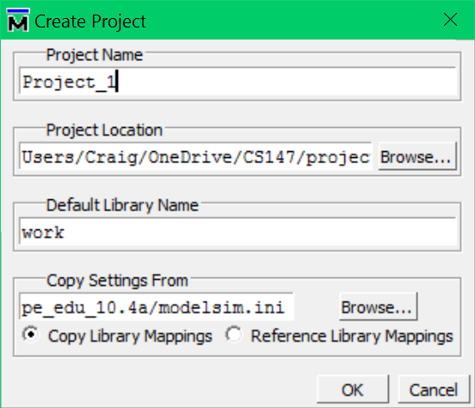
Figure 2.1. Creating a new project

Now that a new project has been made, we can add the files into the project. Since the files necessary for the project have been downloaded, we can use existing files. See figure 2.2

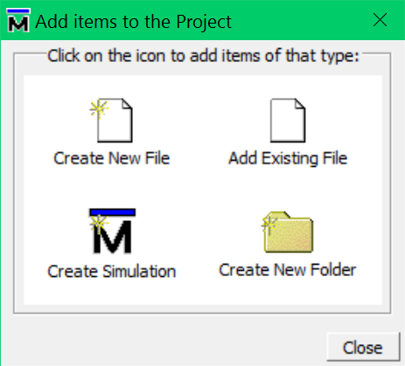
Figure 2.2. Adding existing files

These files will be in the directory of the downloaded .zip file from the step above. Finding and selecting these files is demonstarted in Figures 2.3 and 2.4.

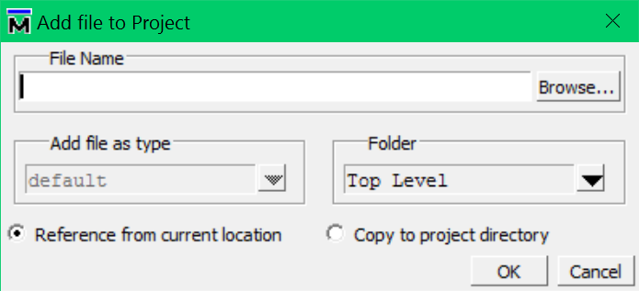
Figure 2.3. Selecting files to be added

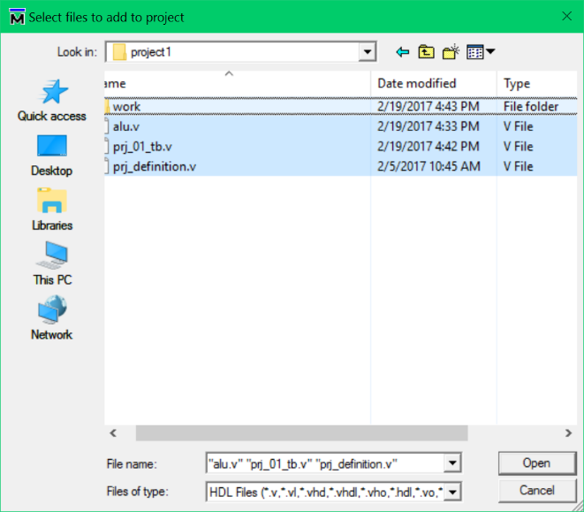
Figure 2.4. Finding the files in the file directory

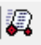

After all the files have been selected and added into the newly created project, the projects must be compiled by pressing the compile button . Compiling the files allows for them to be run after the implementation is complete. The simulator can be started by pressing the simulate button . In the next window that appears, select the work library and the file ‘prj_01_tb’ to start the simulation on the correct file. See Figure 2.5

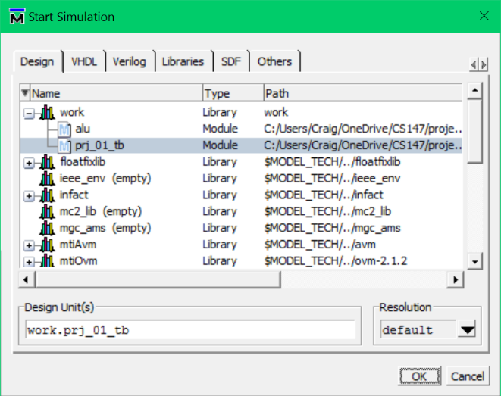
Figure 2.5 Selecting files to simulate

To see the waveforms of the processor while the simulator is running, right click on the file ‘prj_01_tb’ and click ‘Add Wave’ or press ‘Ctrl + W’ on the keyboard as shown in Figure 2.6.

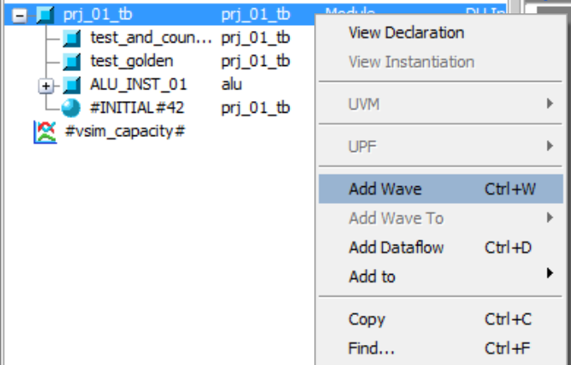
Figure 2.6. Adding waveforms to be watched

Finally, to reset the simulation, specify how long to run the simulation (in nanoseconds), and run the simulation, the buttons that control these functions are displayed in Figure 2.7


Figure 2.7. Tools to run simulations

Requirements of the ALU
The Arithmetic & Logic Unit (ALU) provides the basic functions of a computer. All mathematic and logical programs are handled by the ALU. It is a circuit that handles the logical operations of the processor such as logical AND, OR, NOR, the arithmetic operations of addition, subtraction, multiplication, bitwise AND, bitwise OR, and logical shifts left and right.
All mathematical and logical programs are processed by the ALU and are broken down into the terms of operands and operations. In the program the operands are defined as ‘op1_reg’ and ‘op2_reg’, the operation is defined as ‘oprn_reg’.
The ALU takes the two registers ‘op1_reg’ and ‘op2_reg’ applies the operation specified by ‘oprn_reg’, which is also known as the op-code, and then saves the output in the result ‘r_net’.

Design & Implementation of ALU
Using the ModelSim simulator, it is simple to program the basic functions of the ALU. This section will outline the design of the ALU using the Verilog Hardware Descripting Language (VHDL).

Design Strategy
The design of the ALU is simple. It’s designed to take two operands and one operation as the input and return the result of the process as the output. The ALU built in this project is a 32-bit processor, which makes each of the operands 32-bit, the operand 6-bit, and the output as 32-bit. Each operation implemented in the program is defined with the name ‘ALU_OPRN_WIDTH’h0(#) where the number sign(#) defines the specific operation. For example, 'h02 is Subtraction. The operands have the names ‘op1’ and ‘op2’. The resulting output is referred to as ‘golden’.

Operations Handled by the ALU & Their Implementation
There are nine operations that are handled by the ALU. They are listed as followed with their implementations following.

- ‘'h01’ - Addition: golden = op1 + op2
- ‘'h02’ - Subtraction: golden = op1 − op2
- ‘'h03’ - Multiplication: golden = op1 * op2
- ‘'h04’ - Bitwise AND: golden = op1 & op2
- ‘'h05’ - Bitwise OR: golden = op1 | op2
- ‘'h06’ - Bitwise NOR: golden = ~ (op1 | op2)
- ‘'h07’ - Set Less Than: golden = op1 < op2
- ‘'h08’ - Logical Left Shift: golden = op1 << op2
- ‘'h09’ - Logical Right Shift: golden = op1 >> op2

Test Strategy & Test Implementation
With the implementation done in the file named ‘alu.v. The testing is done in the file named ‘prj_01_tb.v’, which will provide the operands, operations, and record the result to make sure the ALU’s design is correct. Following the instructions from above in Section II to compile and simulate the program, it’s possible to ensure the ALU is designed correctly. The tests are done by comparing the results of the tests named ‘golden’ within the ‘prj_01_tb.v’ file against the results collected from the ‘alu.v’ methods.
Note: All descriptions of the test will be referring to the variables defined in the ‘test_golden’ function defined within the file ‘prj_01_tb.v’

Addition
op1_reg=15;
op2_reg=3;
oprn_reg=`ALU_OPRN_WIDTH'h01;

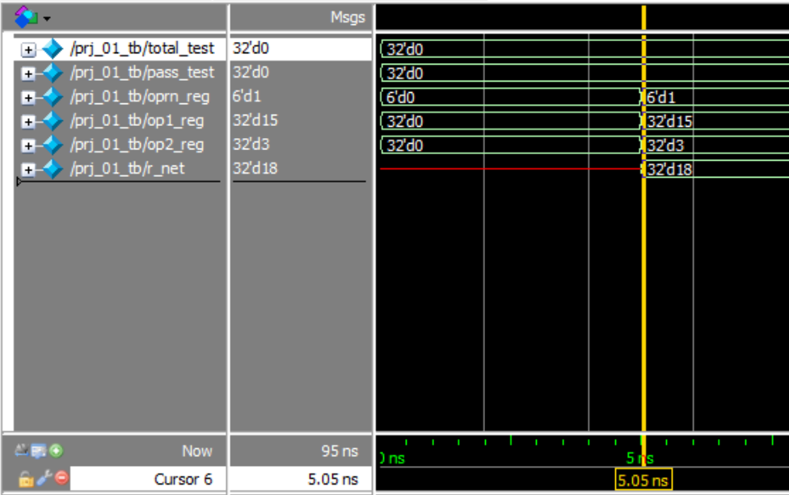
Figure 5.1. Addition Waveform

Subtraction
op1_reg=6;
op2_reg=2;
oprn_reg=`ALU_OPRN_WIDTH'h02;

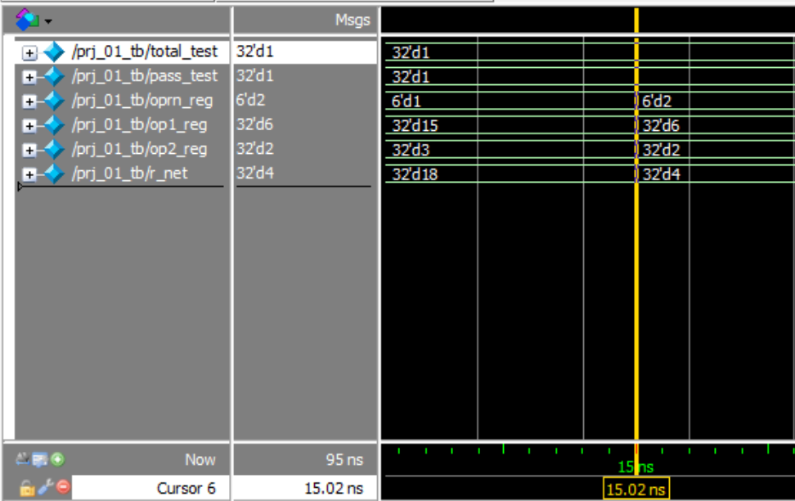
Figure 5.2. Subtraction Waveform

Multiplication
op1_reg=10;
op2_reg=12;
oprn_reg=`ALU_OPRN_WIDTH'h03

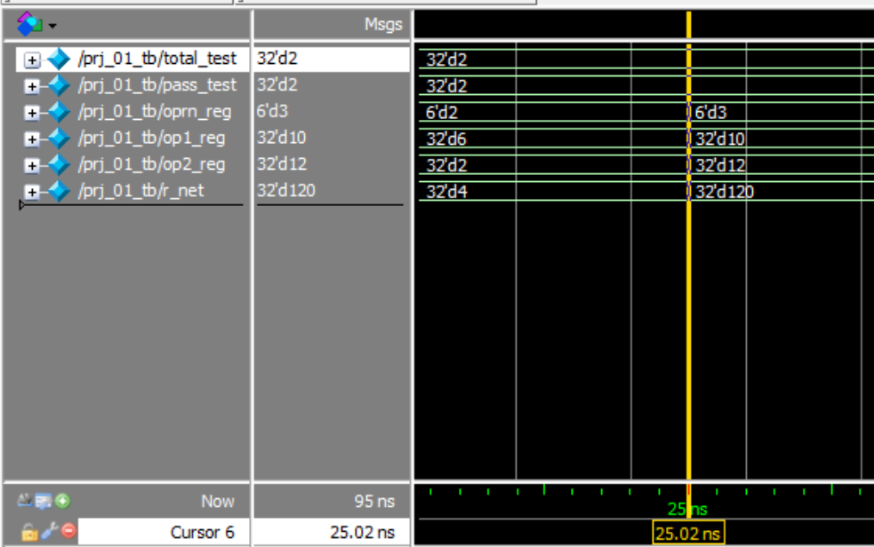
Figure 5.3. Multiplication Waveform

Bitwise AND
op1_reg=26;
op2_reg=3;
oprn_reg=`ALU_OPRN_WIDTH'h04;

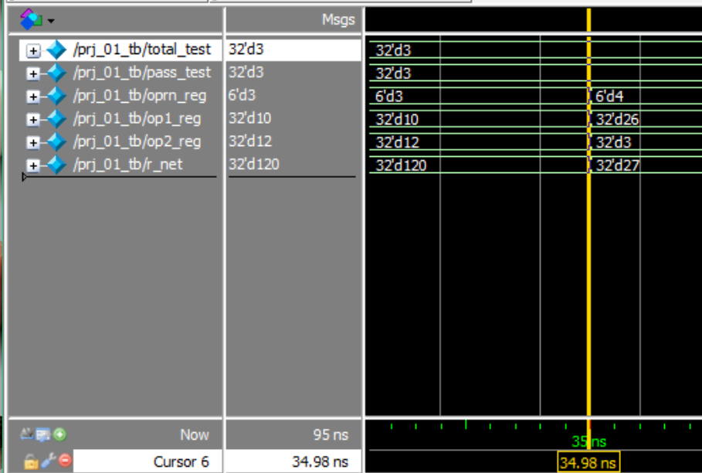
Figure 5.4. Bitwise AND Waveform

Bitwise OR
op1_reg=6;
op2_reg=18;
oprn_reg=`ALU_OPRN_WIDTH'h05;

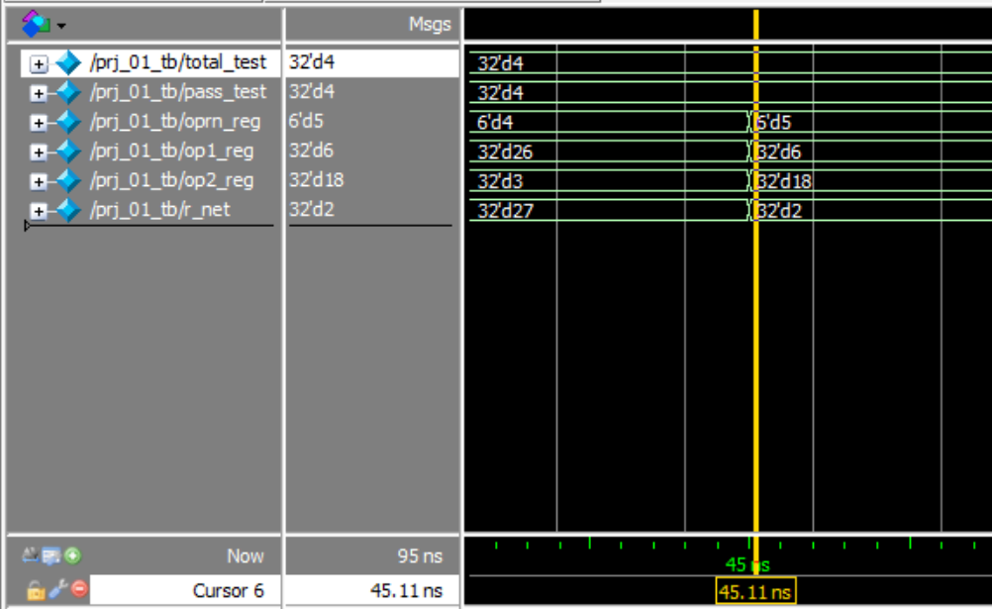
Figure 5.5. Bitwise OR Waveform

Bitwise NOR
op1_reg=7;
op2_reg=1;
oprn_reg=`ALU_OPRN_WIDTH'h06;

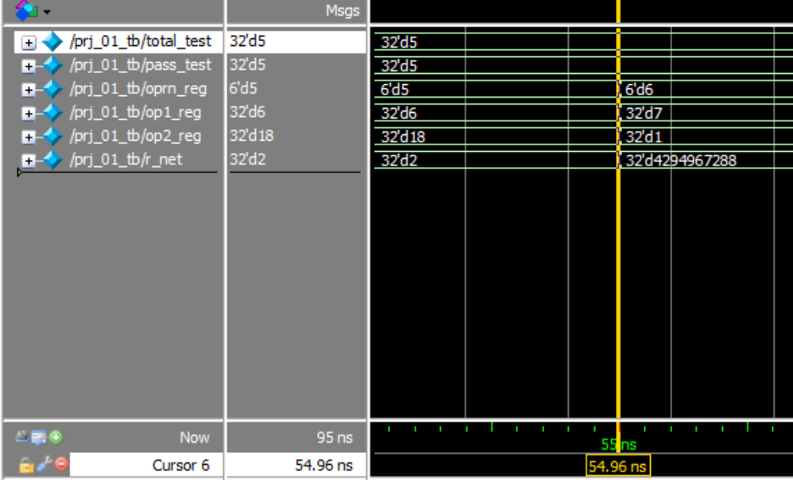
Figure 5.6. Bitwise NOR Waveform

Set Less Than
op1_reg=4;
op2_reg=13;
oprn_reg=`ALU_OPRN_WIDTH'h07;

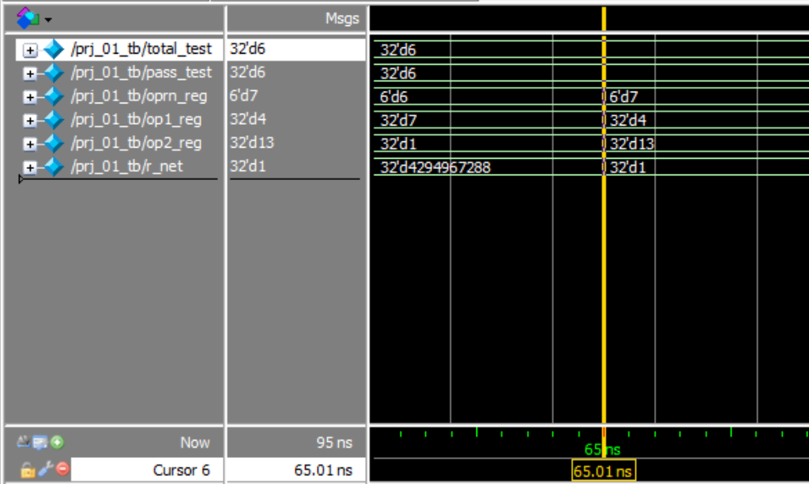
Figure 5.7. Set Less Than Waveform

Logical Shift Left
op1_reg=9;
op2_reg=2;
oprn_reg=`ALU_OPRN_WIDTH'h08;

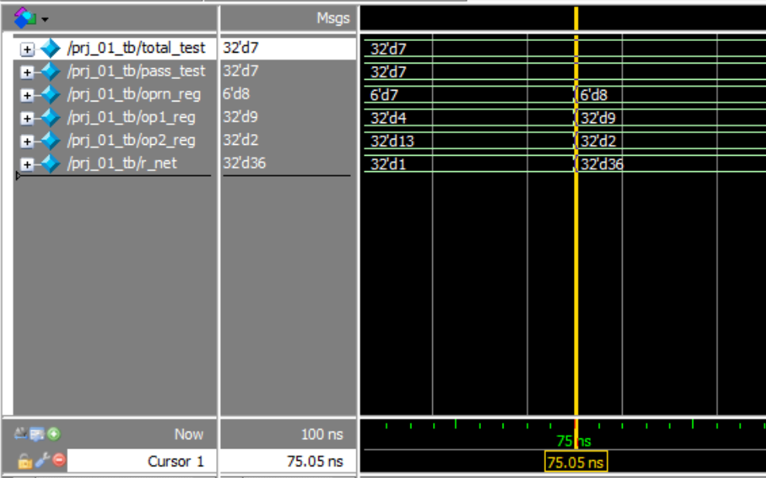
Figure 5.8. Shift Logical Left Waveform

Logical Shift Right
op1_reg=12;
op2_reg=2;
oprn_reg=`ALU_OPRN_WIDTH'h09;
Note: The op2_reg will not change its value in the waveform since the value remains the same from ‘h08 to ‘h09. Therefore, it appears to be gone from the waveform in Figure 5.9.

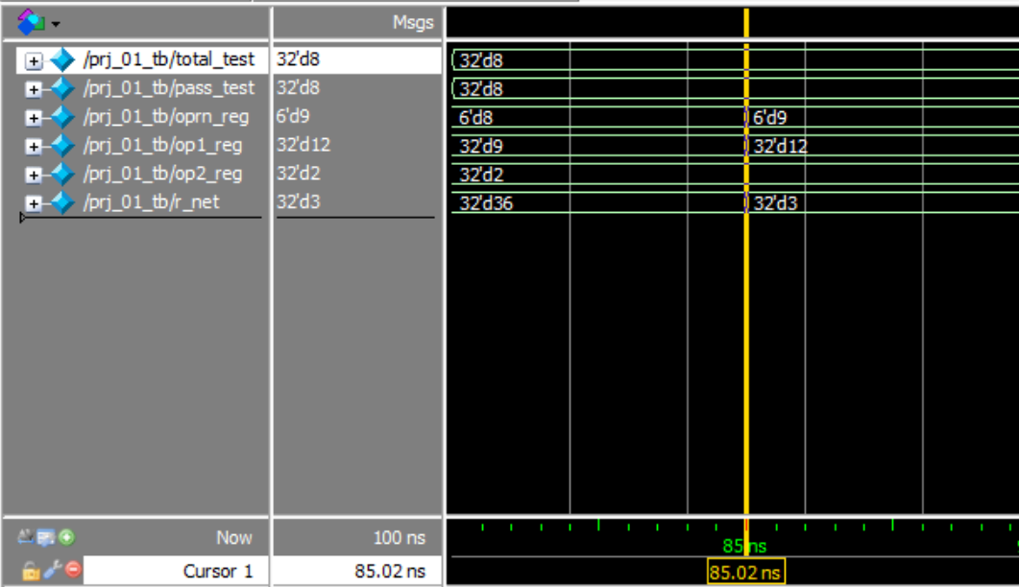
Figure 5.9. Shift Logical Right

The ALU operations test displayed by wavelengths in Figure 5.10 can also be represented in text as is shown in figure 5.11.

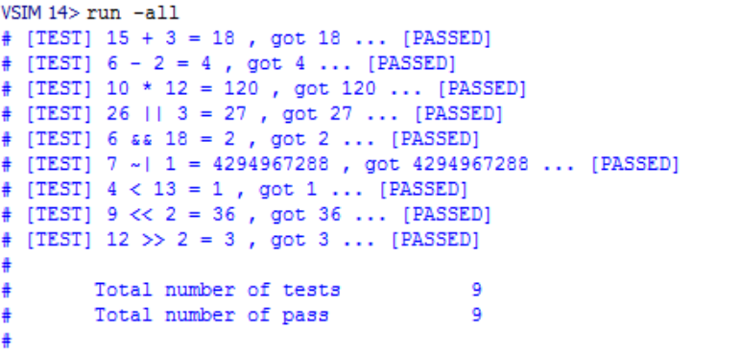Figure 5.10. Results from all ALU tests

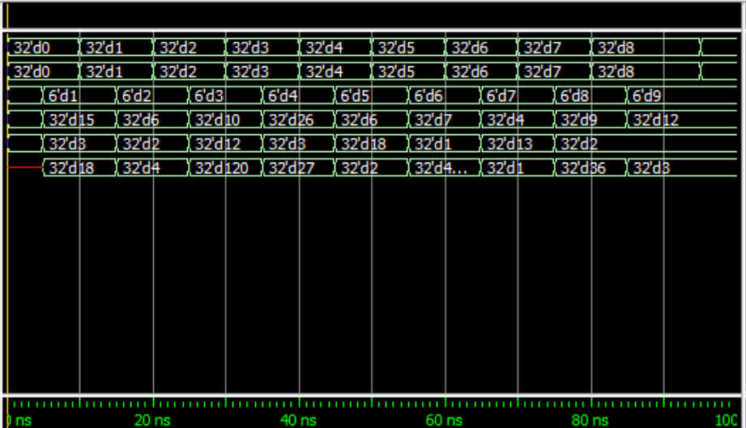
Figure 5.11. Entire Simulation Wavelength

Conclusion
From this project, I learned how to dual boot Windows on a Mac computer, how to install the ModelSim simulator and created a project in the Verilog HDL language. This allowed for me to create a 32-bit Arithmetic & Logic Unit and implement the nine operations defined in ‘CS147 DV’. Overall, I was able to learn a lot about simulations, the waveforms they produce, and how to manipulate projects using the Verilog language.

